# BiQ - Release Validation Lab

***Estimated time required to complete this lab: 45 min***

**NOTE: If you have not created your lab application in Ravello, please execute the following** [**steps**](https://singularity.jira.com/wiki/spaces/ADGS/pages/300647380/Create+a+new+Application+in+Ravello)

1. On Ravello, copy the DNS name address for the 4.4 Controller / Event Server.  Go to [http://](http://controller_ip:8090/)[CONTROLLER_DNS_NAME](http://CONTROLLER_IP:9191)[:8090](http://controller_ip:8090/) in a browser.  You can login to the Controller with the credentials appdadmin / d3m0@ppD.

Validate that you see active load for **AD-Travel**, **eCommerce**, and **fulfillment** applications (**It can take a few minutes for data to start flowing**)

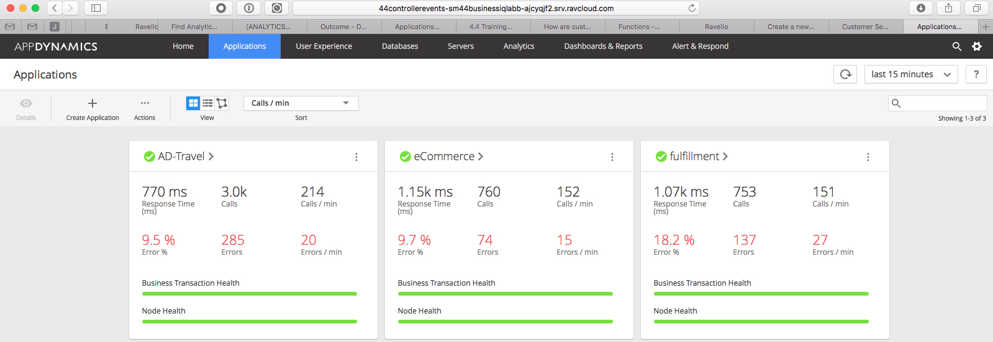

1. To show customers key relevant metrics which have been identified during the BiQ Workshop we are going to use a template dashboard. The Release Validation template dashboard has been already uploaded to your ravello instance.   
   We should somehow work backward to understand which type of widgets may be useful and also what type of Health Rules, ADQL Metrics, ADQL Queries, Data Collectors, Business Transactions (and/or BRUM pages, MRUM network requests) we should create in order to populate our dashboard.
2. Each artifact described before may have dependencies over other artifacts.   
   A quick description of the sequence may be:   
   -Identify key Business Transactions, BRUM pages, MRUM network requests which will be used in the dashboard  
   -Identify and define any required Data Collectors, Custom Events which will be used in the dashboard  
   -Identify and define ADQL queries which may or may not produce additional metrics  
   -Identify and define ADQL metrics which will be used in the dashboard  
   -Identify and define Drag and Drop queries and widgets which will be used in the dashboard  
   -Identify and create Health Rules which will be used in the dashboard
3. For the lab we are not going to spend time on configuring Business Transaction nor Data Collectors, as this should be good and well established practice on the PS team. Data Collectors have already been configured in the lab, please take your time to familiarize with them if you want. Thus, in the lab we will spend more time on creating all the other artifacts required to build our Use Case dashboard.
4. We are going to create all the required artifacts, such ADQL queries, metrics and Health Rules. Let us start with ADQL queries.
5. In the Controller UI, go to Analytics > Searches and create the required ADQL queries to answer the following questions:  
     
   NOTE: Customer uses canary release on node eCom2. We can then compare KPi between node eCom1 (release v1) and node eCom2 (release v2)  
     
   -What is the number of Unique Visitors for release v1?  
     
   SELECT distinctcount(segments.userData.SessionID) FROM transactions WHERE application = "eCommerce" and segments.node = "eCom1"  
     
   -What is the number of Orders Placed for release v1?  
     
   SELECT count(*) FROM transactions WHERE application = "eCommerce" AND transactionName = "CheckOut" AND userExperience != "ERROR" and segments.node = "eCom1"  
     
   -What is the number of Check Out transactions for release v1?  
     
   SELECT count(*) FROM transactions WHERE application = "eCommerce" AND transactionName = "CheckOut" AND segments.node = "eCom1"  
     
   -What is the number of defective Check Out  transactions for release v1?  
     
   SELECT count(*) FROM transactions WHERE application = "eCommerce" AND transactionName = "CheckOut" and userExperience = "ERROR" AND segments.node = "eCom1"  
     
   -What is the average response time for Check Out transactions for release v1?  
     
   SELECT avg(responseTime) FROM transactions WHERE application = "eCommerce" AND transactionName = "CheckOut" AND segments.node = "eCom1"  
     
   **NOTE**: We could have created a single ADQL query to calculate both total transactions and defective Check Out transactions.   
   Actually, the filter function allows us to do this:   
     
   SELECT count(*) AS "All Tx", filter(count(*), WHERE userExperience = "ERROR") FROM transactions WHERE application = "eCommerce" AND transactionName = "CheckOut" AND segments.node = "eCom1"  
     
   But, we could not create metrics for both fields using "Create Metric" feature. If you try you will get an error message like this: "Only single-field queries are allowed as metrics."  
   That is why we had to create two metrics in order to calculate the percentage of defective transactions.
6. Create remaining ADQL queries to answer the following questions:  
     
   -What is the number of Unique Visitors for release v2?  
   -What is the number of Orders Placed for release v2?  
   -What is the number of Check Out transactions for release v2?  
   -What is the number of defective Check Out  transactions for release v2?  
   -What is the average response time for Check Out transactions for release v2?  
     
   -What is the number of Home Page transactions for release v1?    
   -What is the average response time for Home Page transactions for release v1?  
   -What is the number of defective Home Page transactions for release v1?  
     
   -What is the number of Login transactions for release v1?    
   -What is the average response time for Login transactions for release v1?  
   -What is the number of defective Login transactions for release v1?  
     
   -What is the number of Add To Cart transactions for release v1?    
   -What is the average response time for Add To Cart transactions for release v1?  
   -What is the number of defective Add To Cart transactions for release v1?  
     
   -What is the number of Home Page transactions for release v2?    
   -What is the average response time for Home Page transactions for release v2?  
   -What is the number of defective Home Page transactions for release v2?  
     
   -What is the number of Login transactions for release v2?    
   -What is the average response time for Login transactions for release v2?  
   -What is the number of defective Login transactions for release v2?  
     
   -What is the number of Add To Cart transactions for release v2?    
   -What is the average response time for Add To Cart transactions for release v2?  
   -What is the number of defective Add To Cart transactions for release v2?
7. In the Controller UI, go to Analytics > Metrics and create the required metrics (you can use the ADQL queries created in the previous step):   
     
   -Number of Unique Visitors for release v1  
   -Number of Orders Placed for release v1  
   -Number of Check Out transactions for release v1  
   -Number of defective Check Out transactions for release v1  
   -Average response time for Check Out transactions for release v1  
     
   -Number of Home Page transactions for release v1  
   -Number of defective Home Page transactions for release v1  
   -Average response time for Home Page transactions for release v1  
     
   -Number of Login transactions for release v1  
   -Number of defective Login transactions for release v1  
   -Average response time for Login transactions for release v1  
     
   -Number of Add To Cart transactions for release v1  
   -Number of defective Add To Cart transactions for release v1  
   -Average response time for Add To Cart transactions for release v1  
     
   -Number of Unique Visitors for release v2  
   -Number of Orders Placed for release v2  
   -Number of Check Out transactions for release v2  
   -Number of defective Check Out transactions for release v2  
   -Average response time for Check Out transactions for release v2  
     
   -Number of Home Page transactions for release v2  
   -Number of defective Home Page transactions for release v2  
   -Average response time for Home Page transactions for release v2  
     
   -Number of Login transactions for release v2  
   -Number of defective Login transactions for release v2  
   -Average response time for Login transactions for release v2  
     
   -Number of Add To Cart transactions for release v2  
   -Number of defective Add To Cart transactions for release v2  
   -Average response time for Add To Cart transactions for release v2
8. In the Controller UI, go to Analytics > Alert & Respond > Health Rules and create the required Health Rules for the metrics defined in step 10:  
     
   -eComm - Check Out Errors higher than expected - v1  
     
   Critical condition: ({TXwithErrors}/{TX}*100) > 30 (%)  
   Warning condition: ({TXwithErrors}/{TX}*100) > 10 (%)  
     
     
     
     
     
   -eComm - Check Out RT higher than expected - v1  
     
   Critical condition: AVG RT > 2000 (ms)  
   Warning condition: AVG RT > 1000 (ms)  
     
     
     
     
     
   -eComm - Home Page Errors higher than expected - v1  
     
   Critical condition: ({TXwithErrors}/{TX}*100) > 30 (%)  
   Warning condition: ({TXwithErrors}/{TX}*100) > 10 (%)  
     
     
     
     
     
     
   -eComm - Home Page RT higher than expected - v1  
     
   Critical condition: AVG RT > 2000 (ms)  
   Warning condition: AVG RT > 1000 (ms)  
     
     
     
     
     
   -eComm - Login Errors higher than expected - v1  
     
   Critical condition: ({TXwithErrors}/{TX}*100) > 30 (%)  
   Warning condition: ({TXwithErrors}/{TX}*100) > 10 (%)  
     
     
     
     
     
     
   -eComm - Login  RT higher than expected - v1  
     
   Critical condition: AVG RT > 2000 (ms)  
   Warning condition: AVG RT > 1000 (ms)  
     
     
     
     
     
   -eComm - Add To Cart Errors higher than expected - v1  
     
   Critical condition: ({TXwithErrors}/{TX}*100) > 30 (%)  
   Warning condition: ({TXwithErrors}/{TX}*100) > 10 (%)  
     
     
     
     
     
   -eComm - Add To Cart RT higher than expected - v1  
     
   Critical condition: AVG RT > 2000 (ms)  
   Warning condition: AVG RT > 1000 (ms)

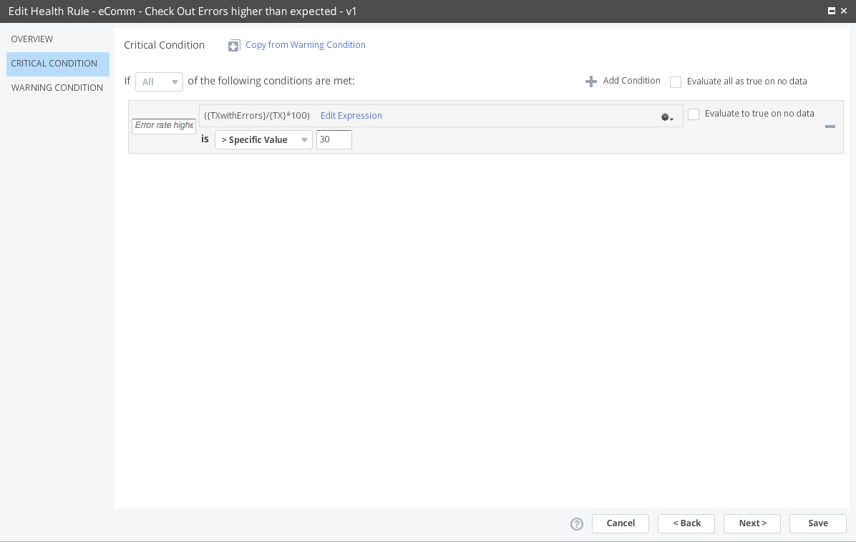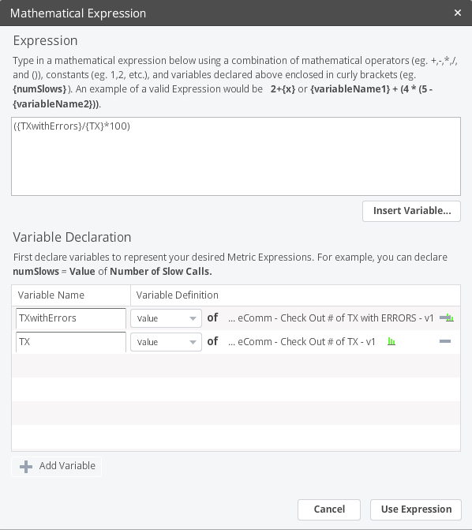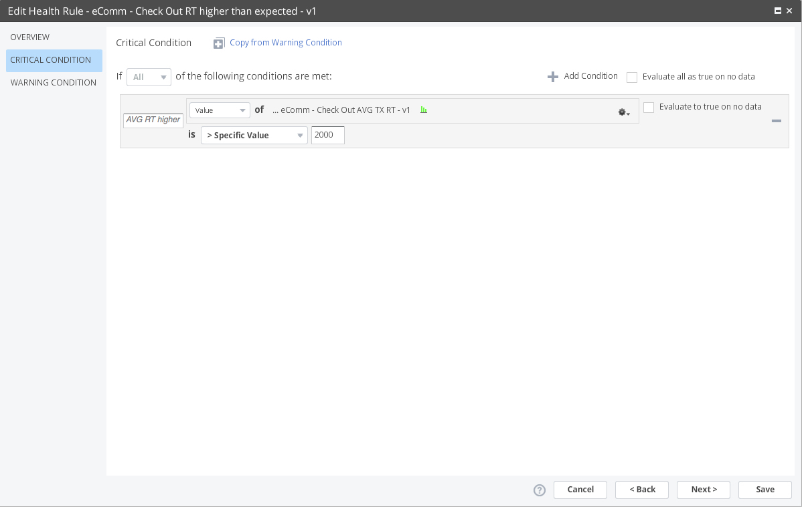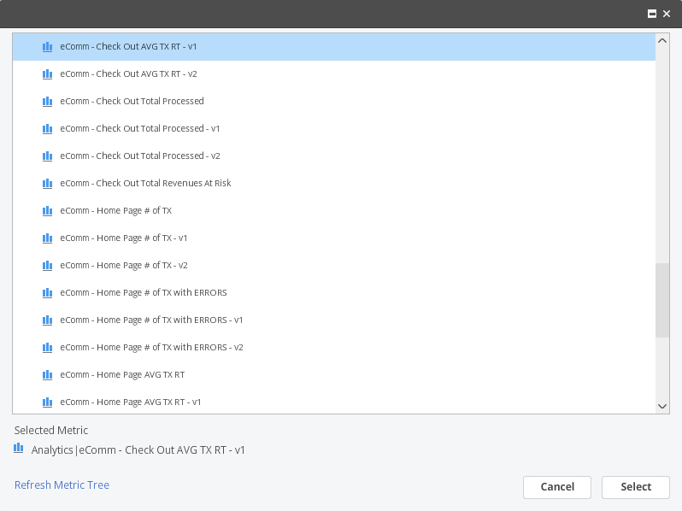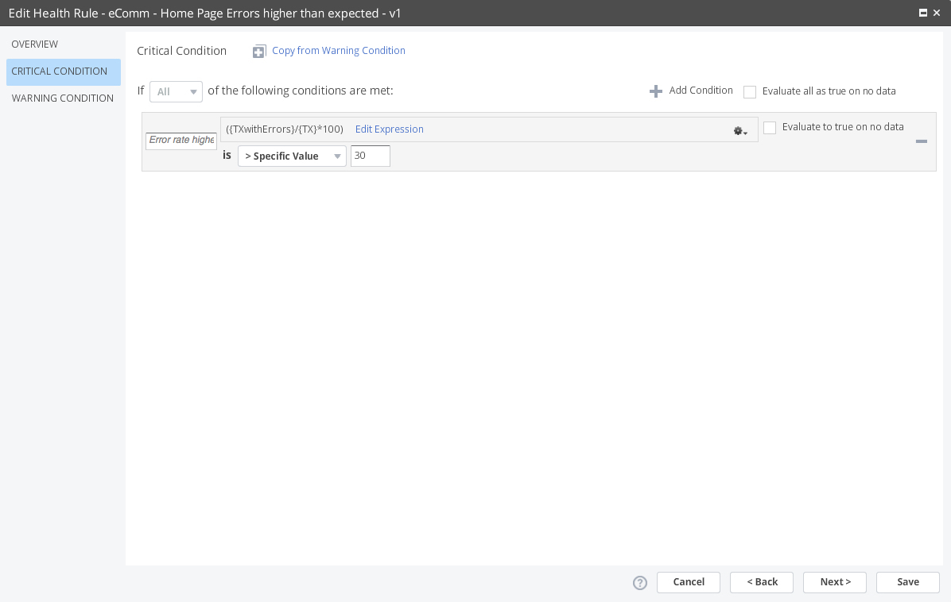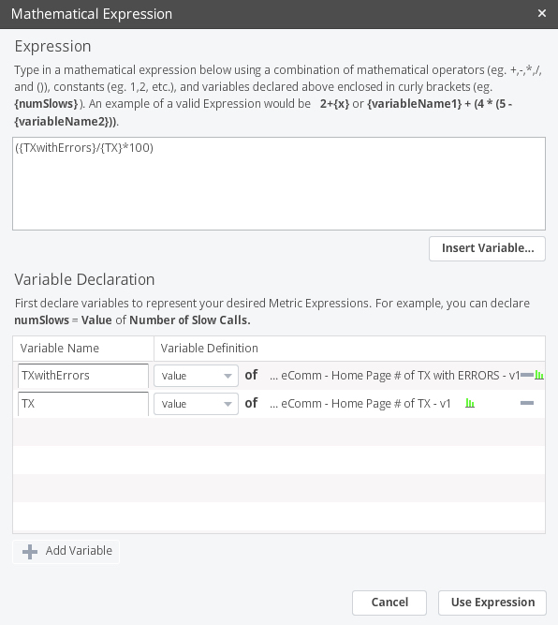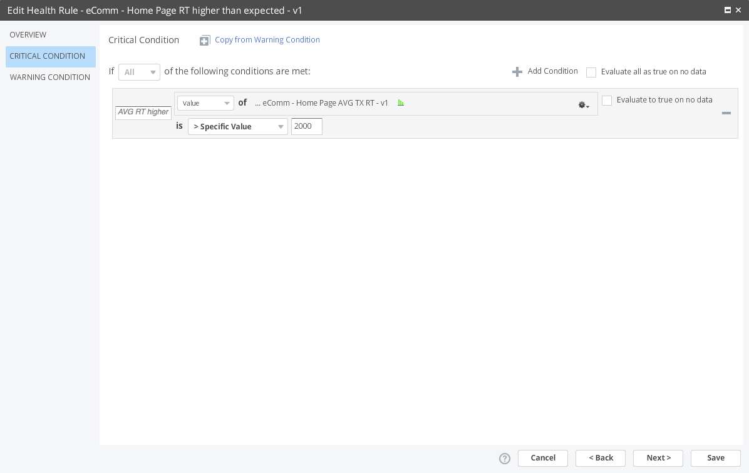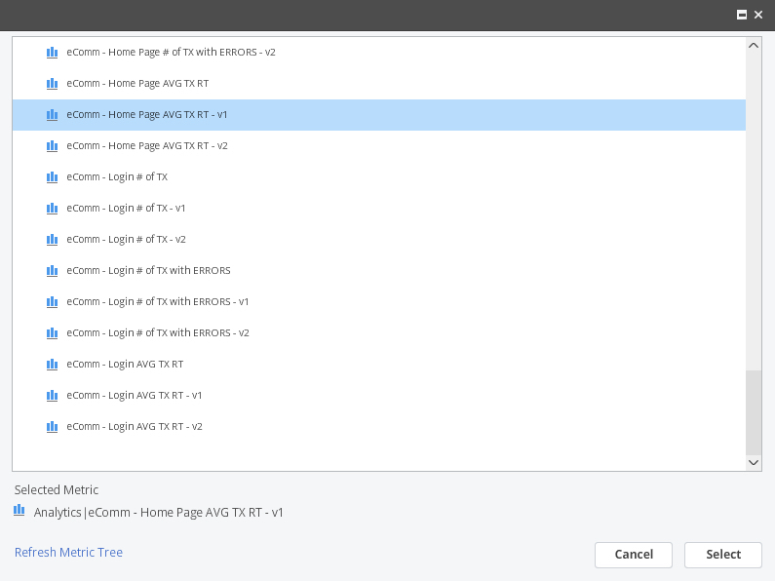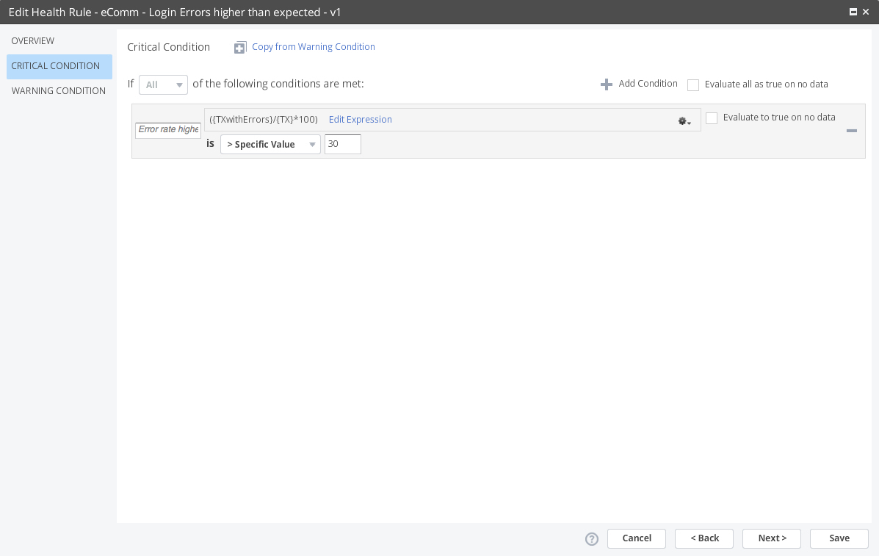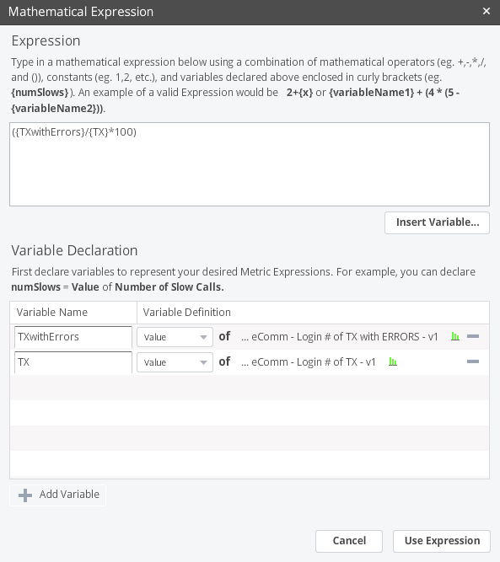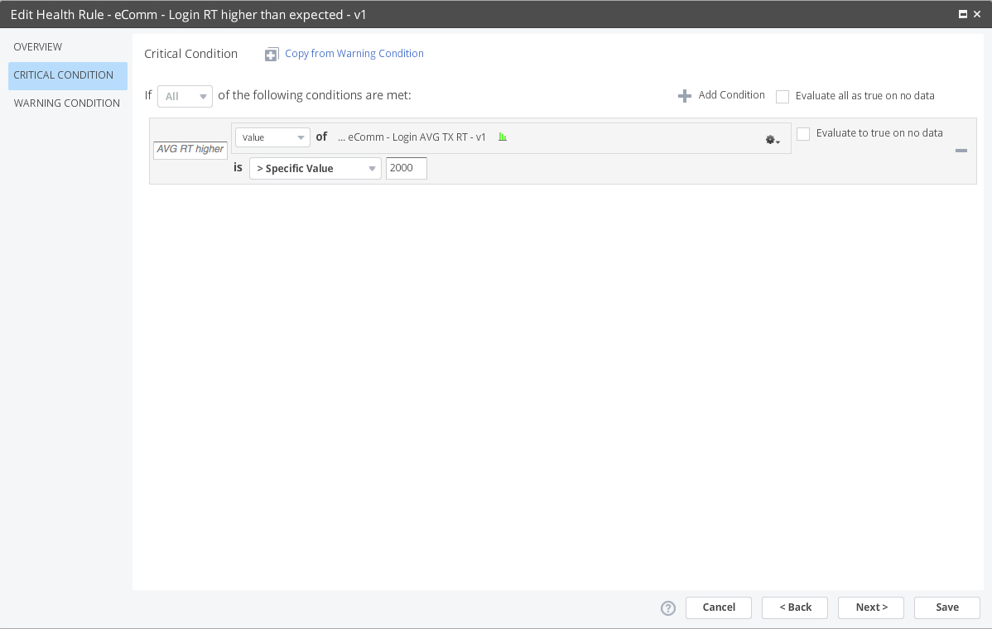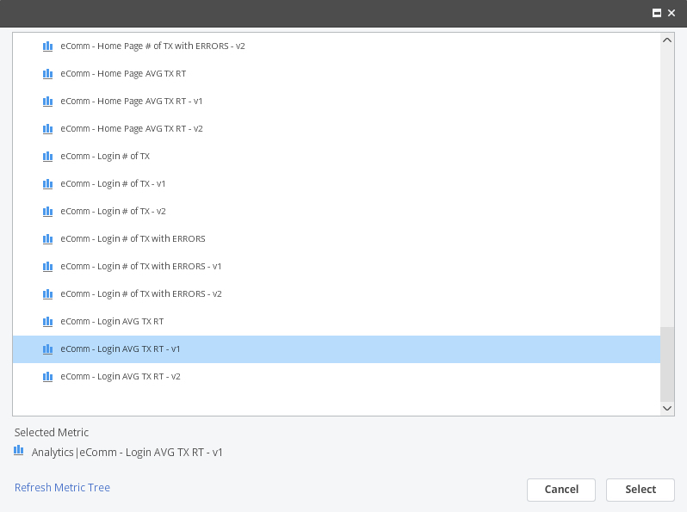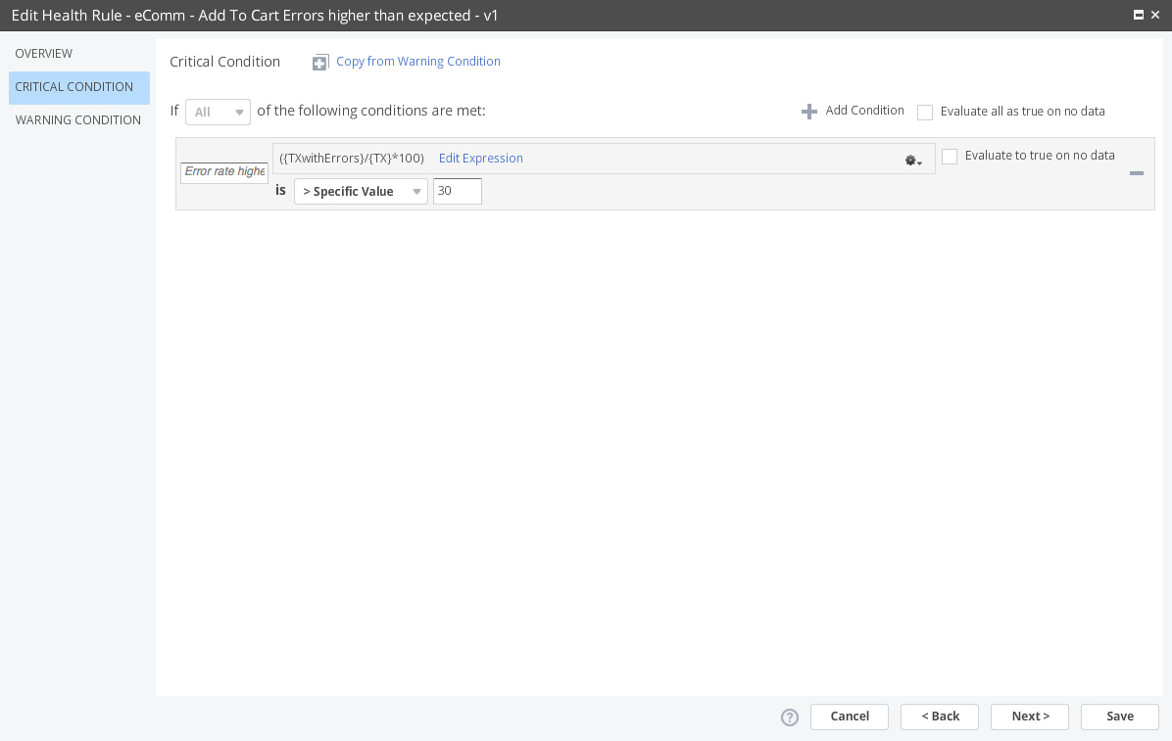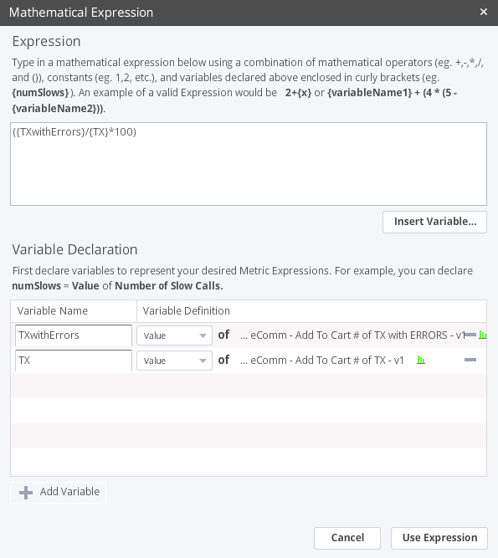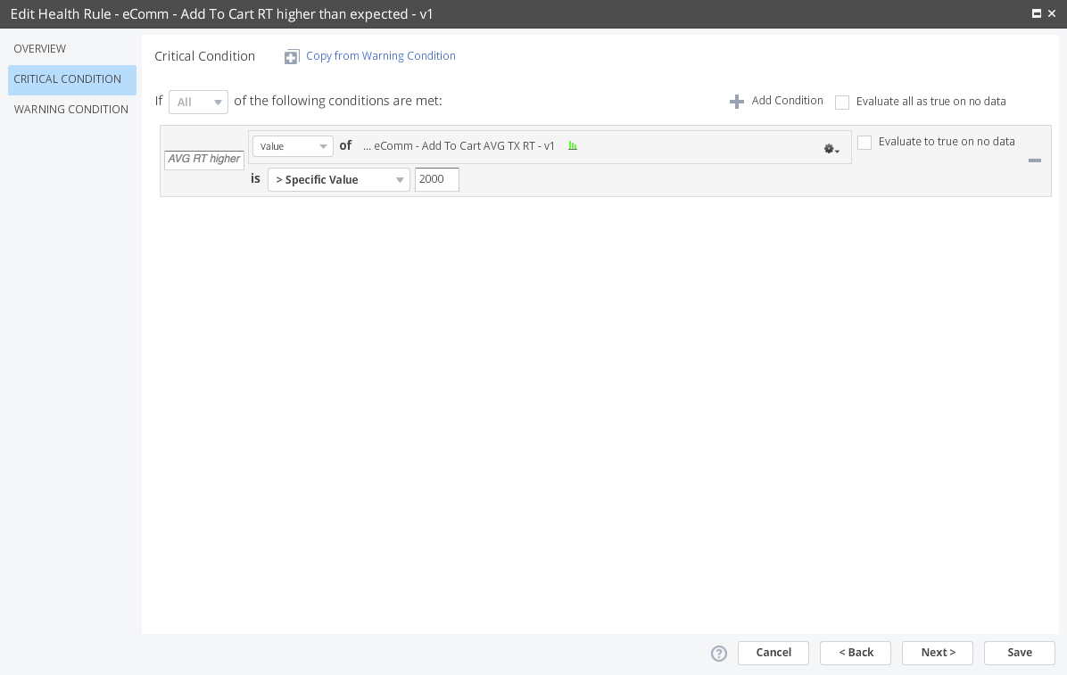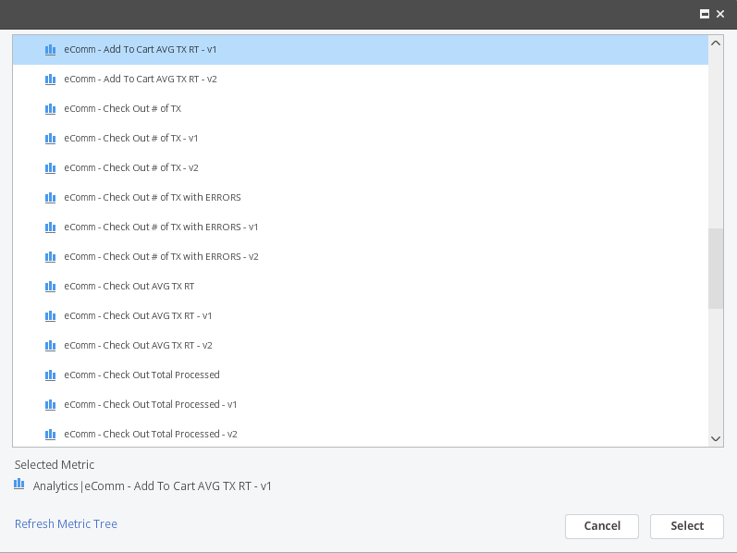

1. Create the remaining Health Rules for the metrics defined in step 10:  
     
   -eComm - Check Out Errors higher than expected - v2  
   -eComm - Check Out RT higher than expected - v2  
   -eComm - Home Page Errors higher than expected - v2  
   -eComm - Home Page RT higher than expected - v2  
   -eComm - Login Errors higher than expected - v2  
   -eComm - Login  RT higher than expected - v2  
   -eComm - Add To Cart Errors higher than expected - v2  
   -eComm - Add To Cart RT higher than expected - v2
2. In the Controller UI, go to Dashboards & Reports and edit your Release Validation dashboard.  
     
   On the top side of your dashboard, use the metric value widgets to show:  
     
   -Active Sessions for v1  
     
     
     
     
     
   -% Sales Conversion for v1   
     
   NOTE: use metric expression ({# of Sales}/{# of Unique Visitors} * 100)  
     
     
     
     
     
     
     
   -# of Orders for v1

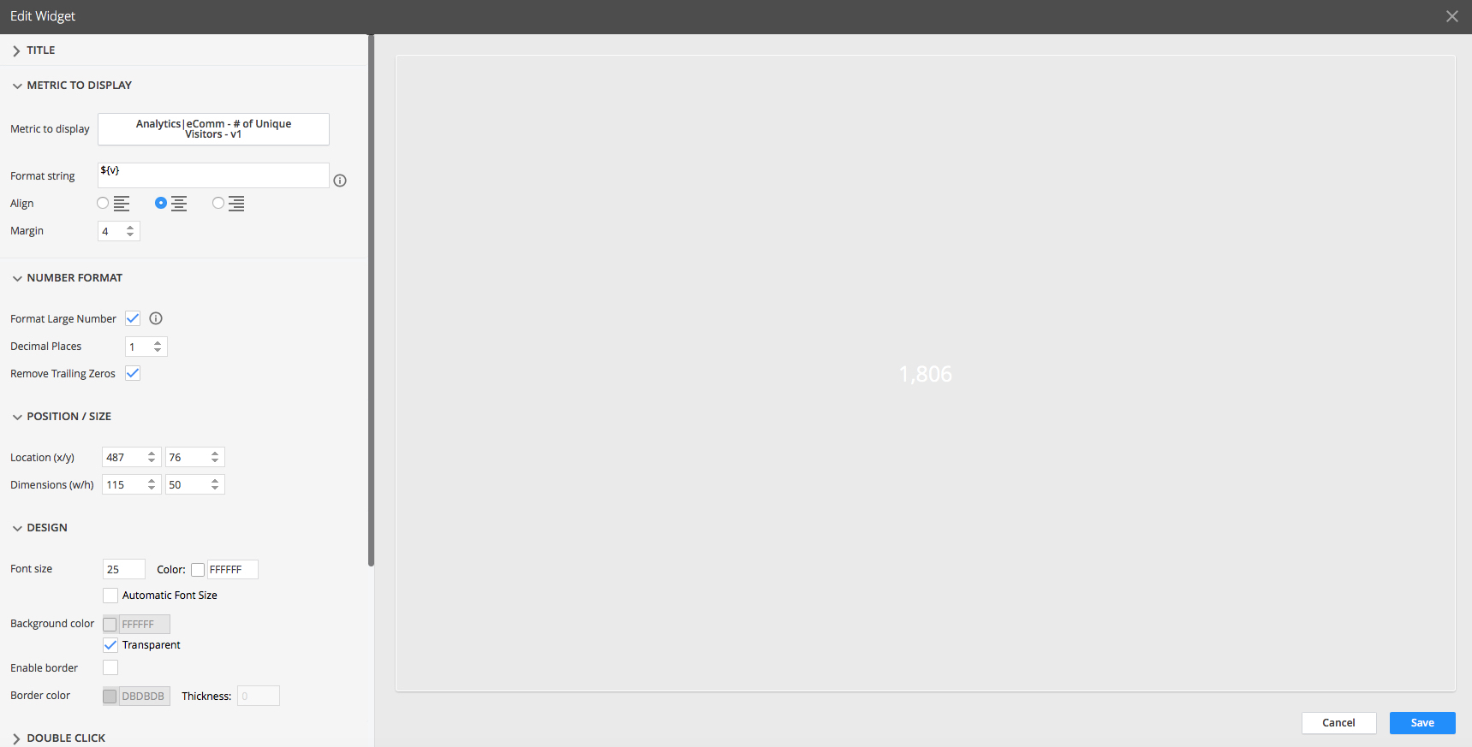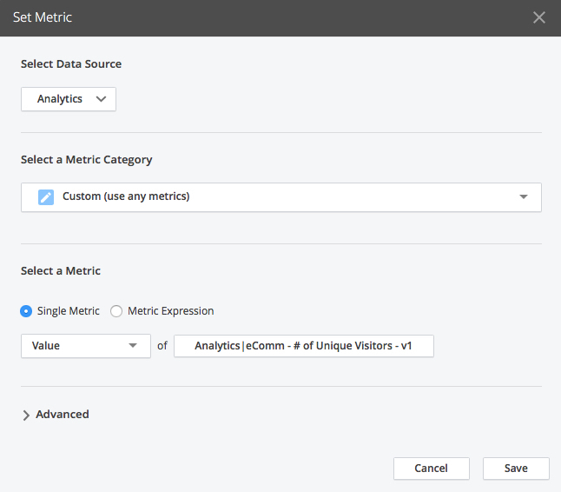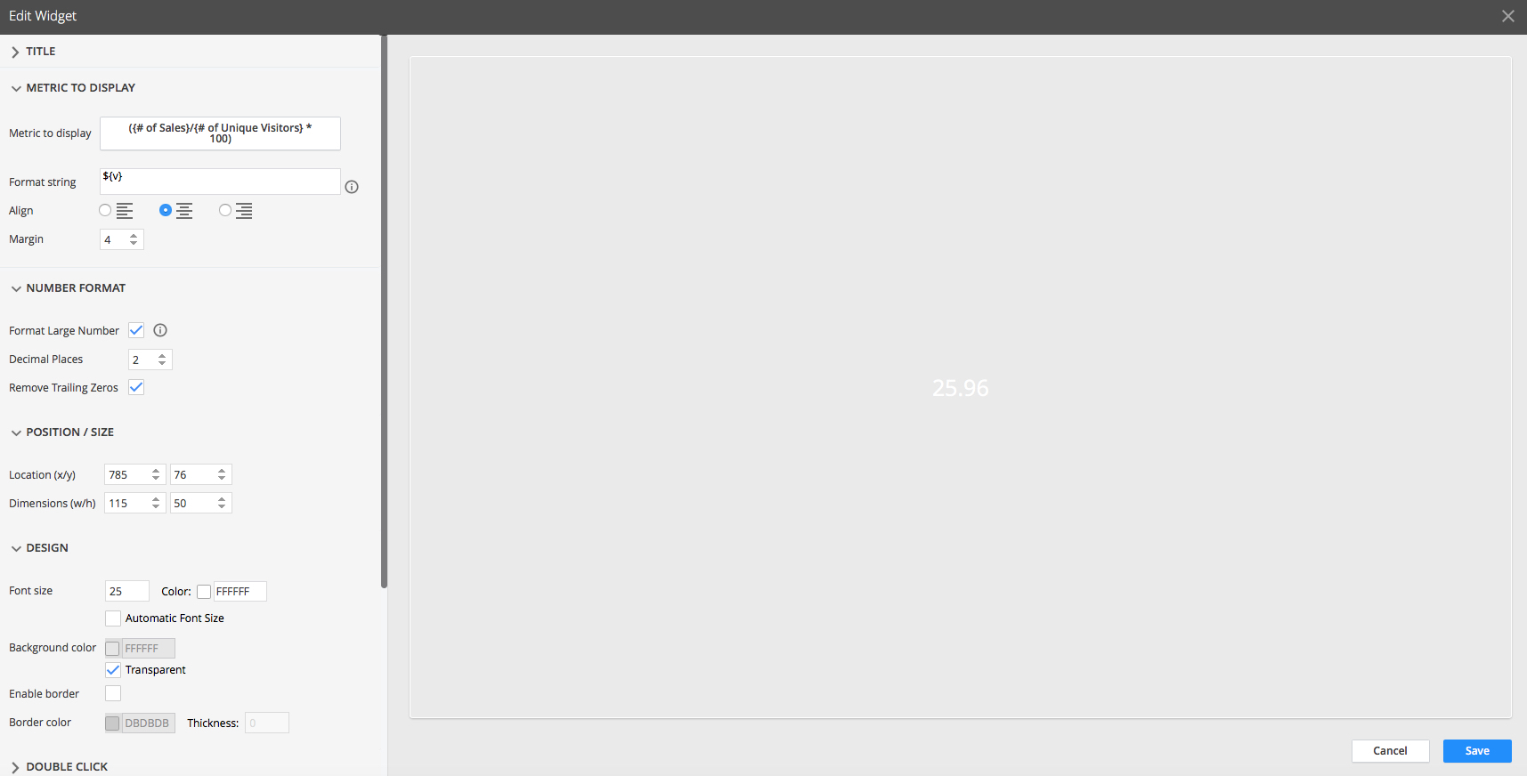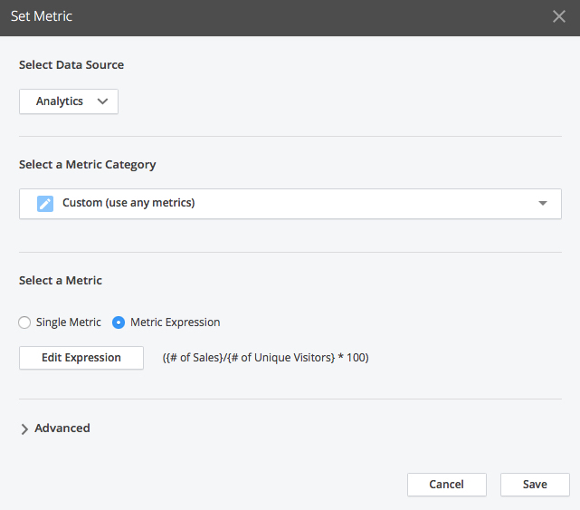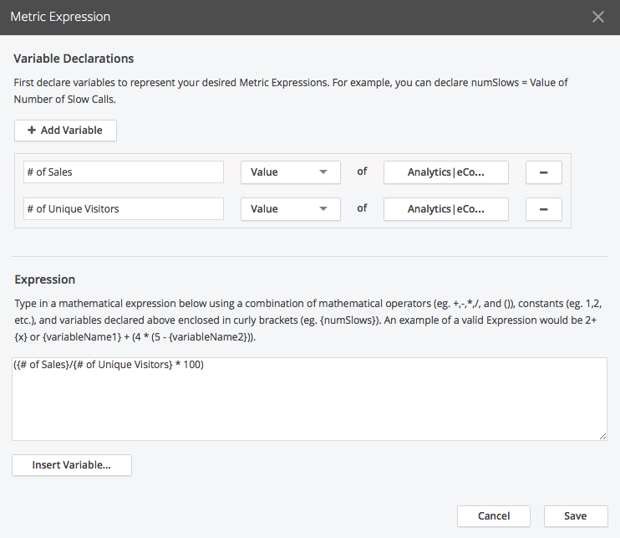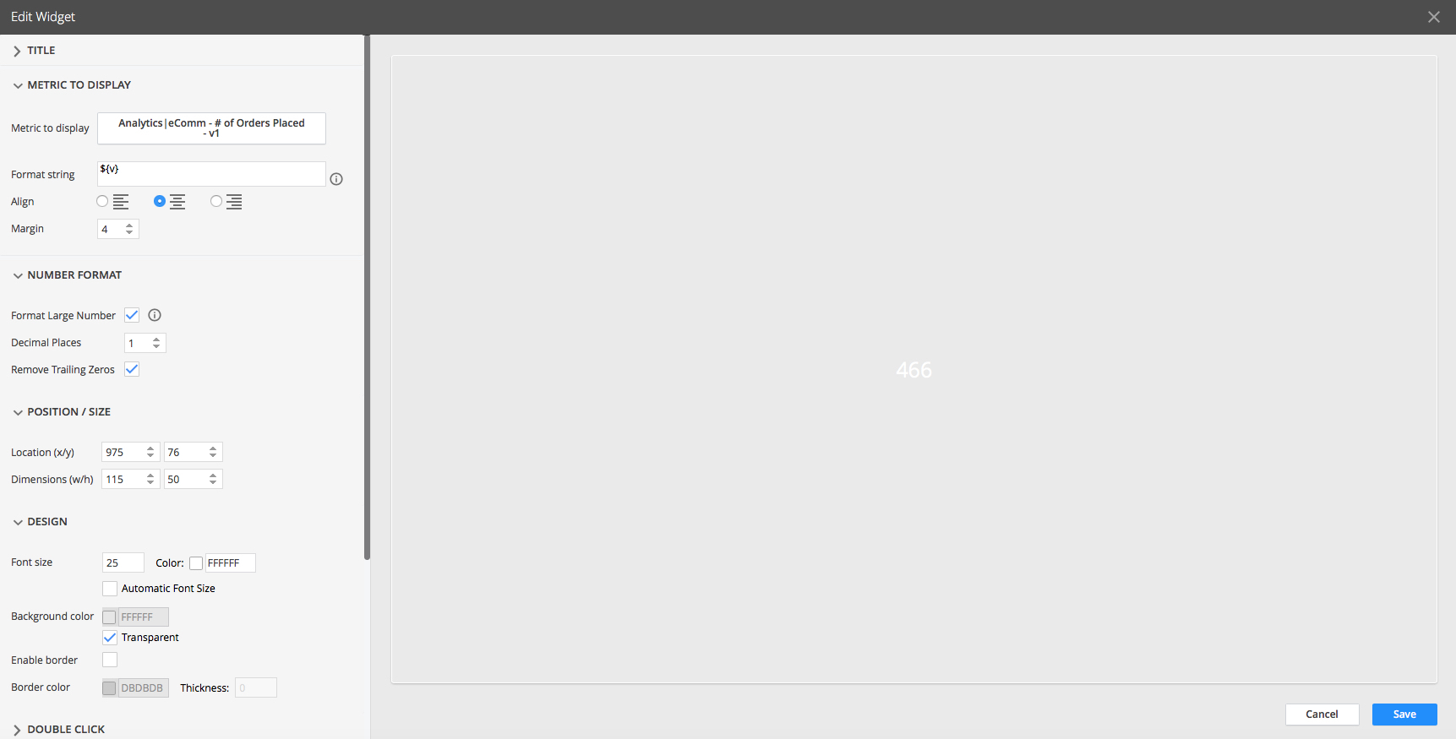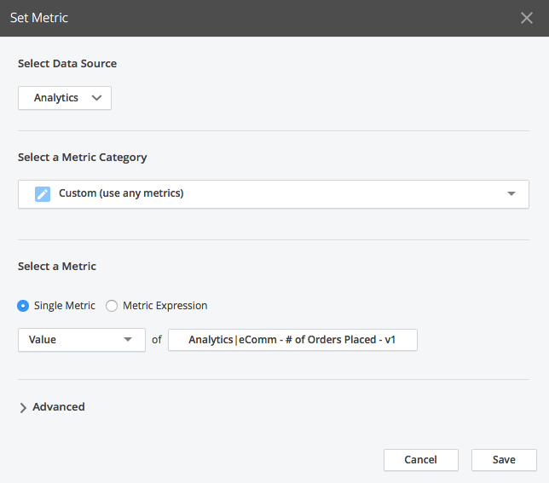

1. Complete the top side of your Release Validation dashboard, use the metric value widgets to show the remaining metrics:  
     
   -Active Sessions for v2  
     
   -% Sales Conversion for v2  
   NOTE: use metric expression ({# of Sales}/{# of Unique Visitors} * 100)  
     
   -# of Orders for v2
2. In the Controller UI, go to Dashboards & Reports and edit your Release Validation dashboard. We are going to add two Time series Graph widgets to show % Sales Conversion trend for release v1 and v2  
     
     
     
   On the left time series graph widget use the metric expression: ({Sales}/{UniqueVisitors}*100)  
   NOTE: Order Placed on release v1 divided by UniqueVisitors on release v1  
     
     
     
     
     
     
     
     
   On the right time series graph widget use the metric expression: ({Sales}/{UniqueVisitors}*100)  
   NOTE: Order Placed on release v2 divided by UniqueVisitors on release v2

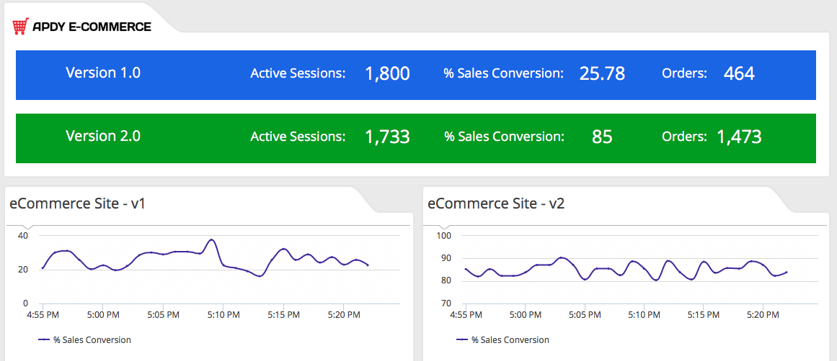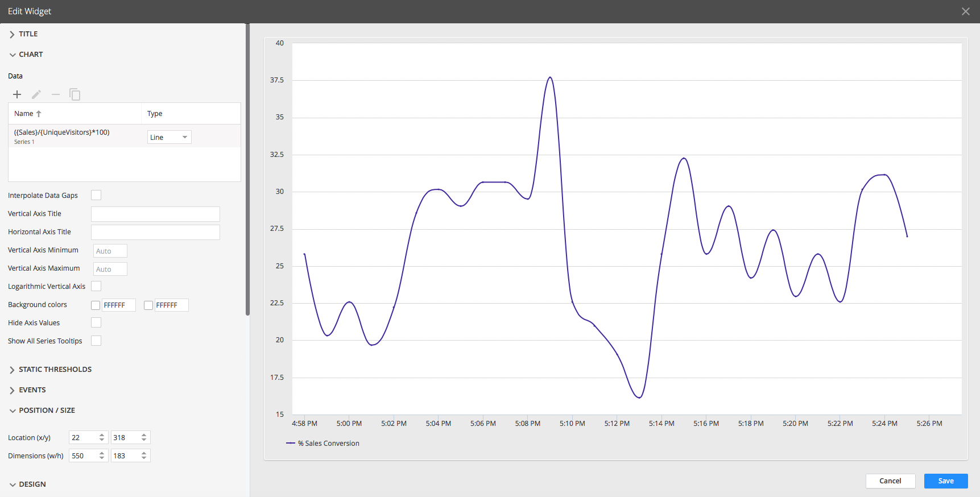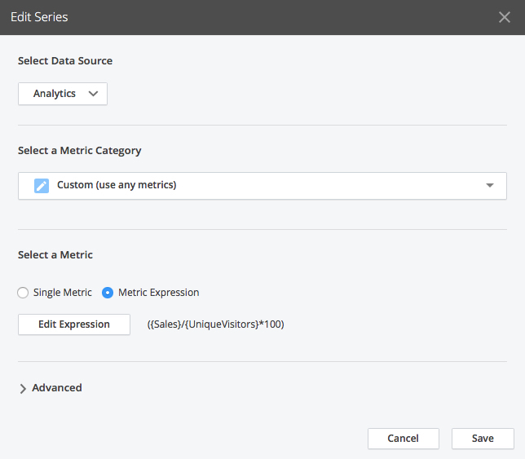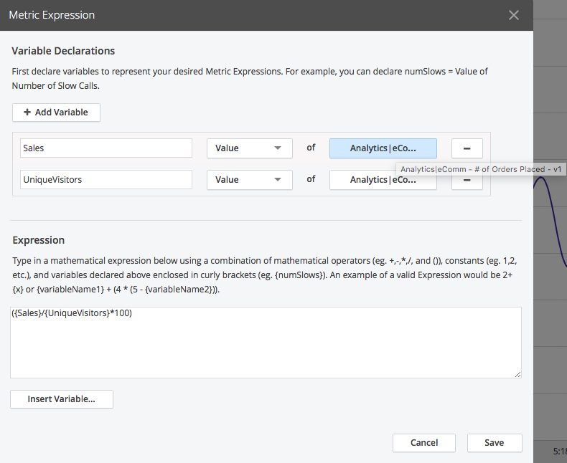

1. In the Controller UI, go to Dashboards & Reports and edit your Release Validation dashboard. We are going to add two funnel widgets to compare release v1 with v2.  
   To add a new Funnel go to Add Widget > Analytics > Funnel Analysis and use a Funnel widget to answer the following questions:  
     
     
     
     
   -Given the following user journey Home Page > Login > Add To Cart > Check Out, what is the conversion rate for eCommerce Check Outs on release v1?  
     
     
     
   Use the following Funnel properties:  
     
   Alignment: Center  
   Show Health: checked   
     
     
     
   Use the following Funnel definitions:

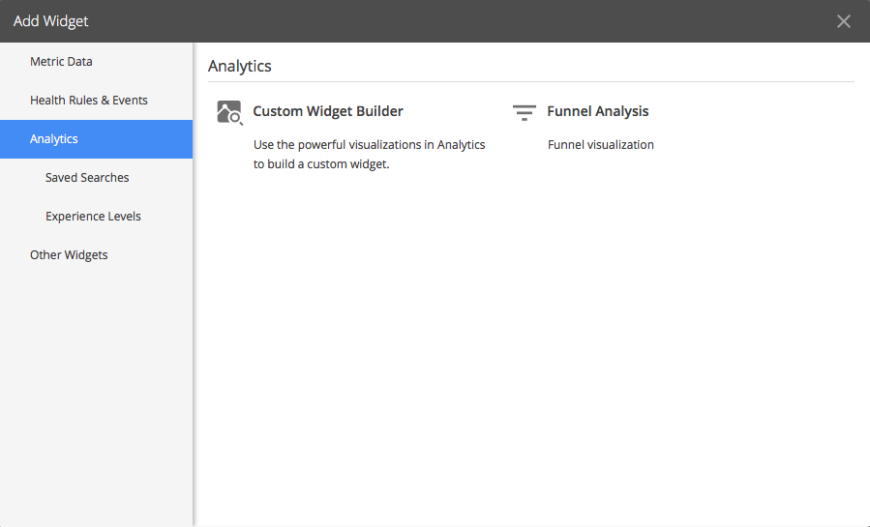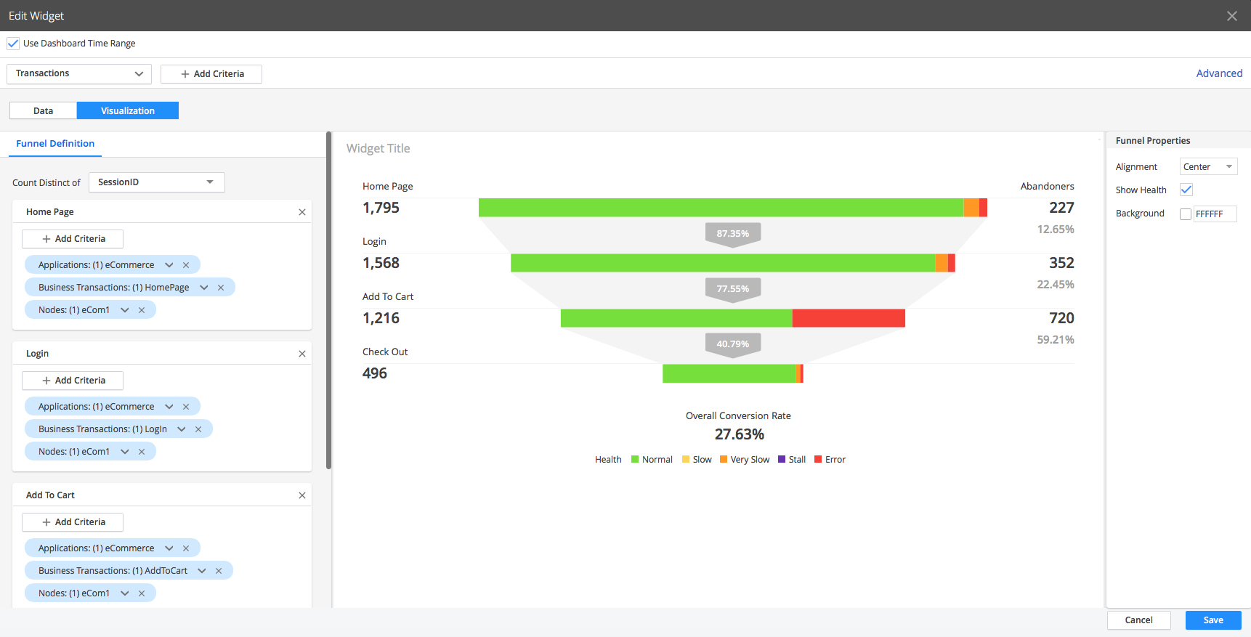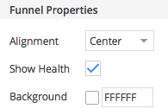

Count Distinct of: SessionID

Use the following criteria for the various steps:   
  
Step name: Home Page  
Application: eCommerce  
Business Transaction: HomePage   
Nodes: eCom1   
  
Step name: Login  
Application: eCommerce  
Business Transaction:  Login   
Nodes: eCom1   
  
Step name: Add To Cart  
Application: eCommerce  
Business Transaction:  AddToCart   
Nodes: eCom1   
  
Step name: Check Out  
Application: eCommerce  
Business Transaction:  CheckOut  
Nodes: eCom1

Save the funnel and position it on the bottom left of your dashboard:  
  
  
  
-Given the following user journey Home Page > Login > Add To Cart > Check Out, what is the conversion rate for eCommerce Check Outs on release v2?  
  
  
  
Use the following Funnel properties:  
  
Alignment: Center  
Show Health: checked   
  
  
  
Use the following Funnel definitions:

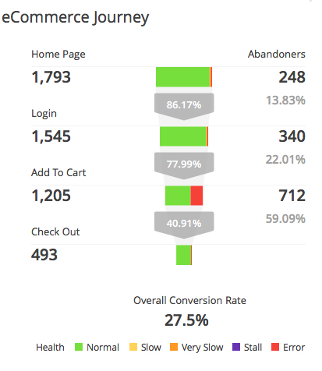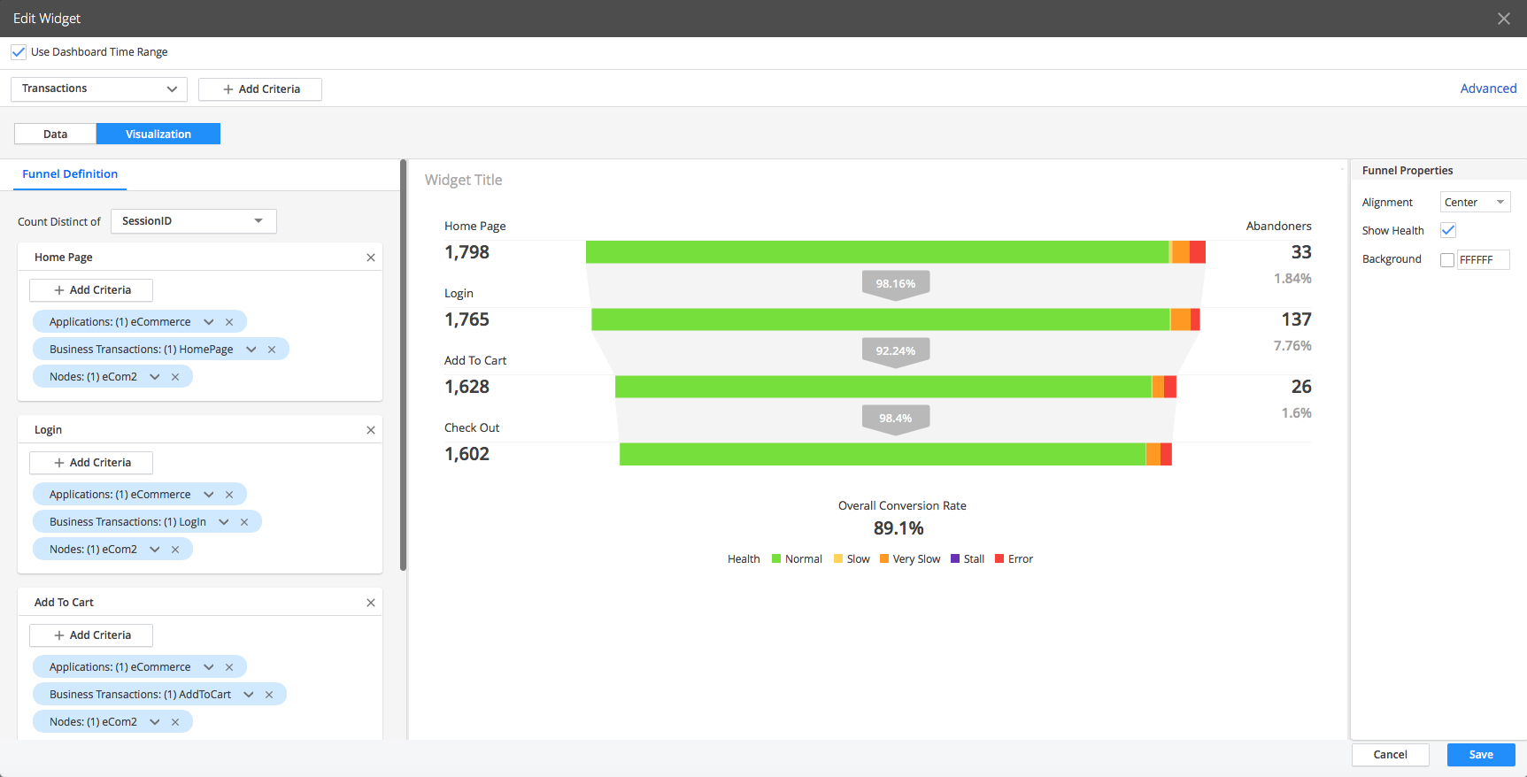

Count Distinct of: SessionID

Use the following criteria for the various steps:   
  
Step name: Home Page  
Application: eCommerce  
Business Transaction: HomePage   
Nodes: eCom2   
  
Step name: Login  
Application: eCommerce  
Business Transaction:  Login   
Nodes: eCom2   
  
Step name: Add To Cart  
Application: eCommerce  
Business Transaction:  AddToCart   
Nodes: eCom2   
  
Step name: Check Out  
Application: eCommerce  
Business Transaction:  CheckOut  
Nodes: eCom2

Save the funnel and position it on the bottom right of your dashboard:

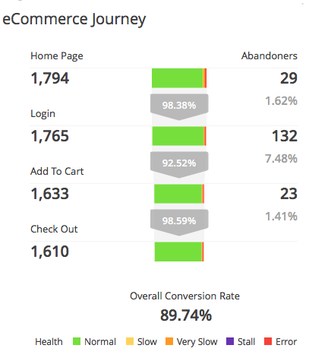

1. In the Controller UI, go to Dashboards & Reports and edit your Release Validation dashboard. Link the Health Status widget with the relative Health Rules  -Next to the left funnel widget, for each business transactions, use the health status widget to link with the respective average response time and the percentage of defective transactions Health Rules for release v1 (created in step 11):  
     
     
     
   -eComm - Add To Cart RT higher than expected - v1  
     
     
     
     
     
   -eComm - Add To Cart Errors higher than expected - v1

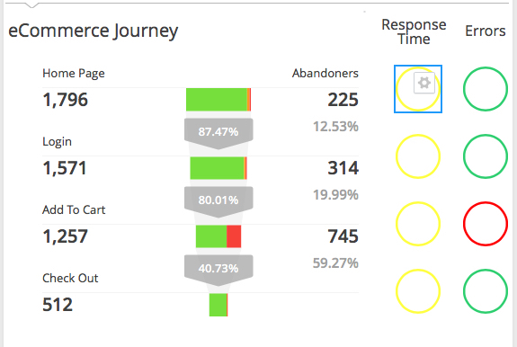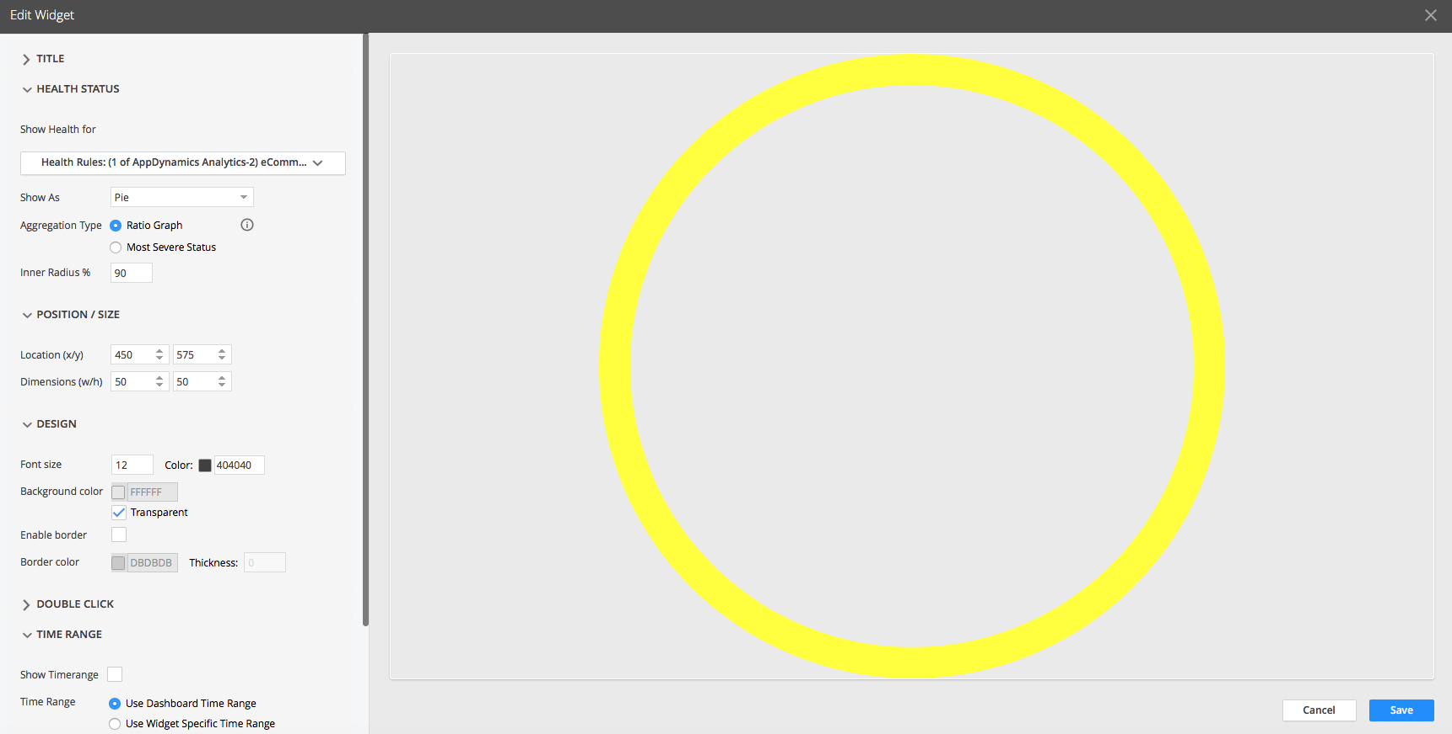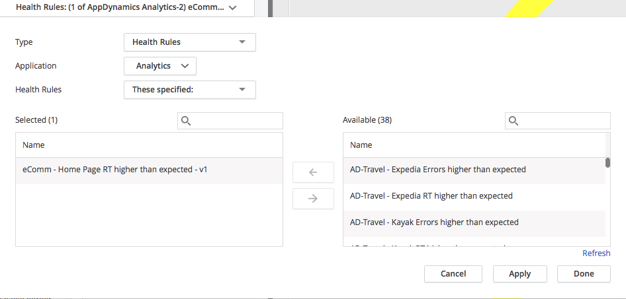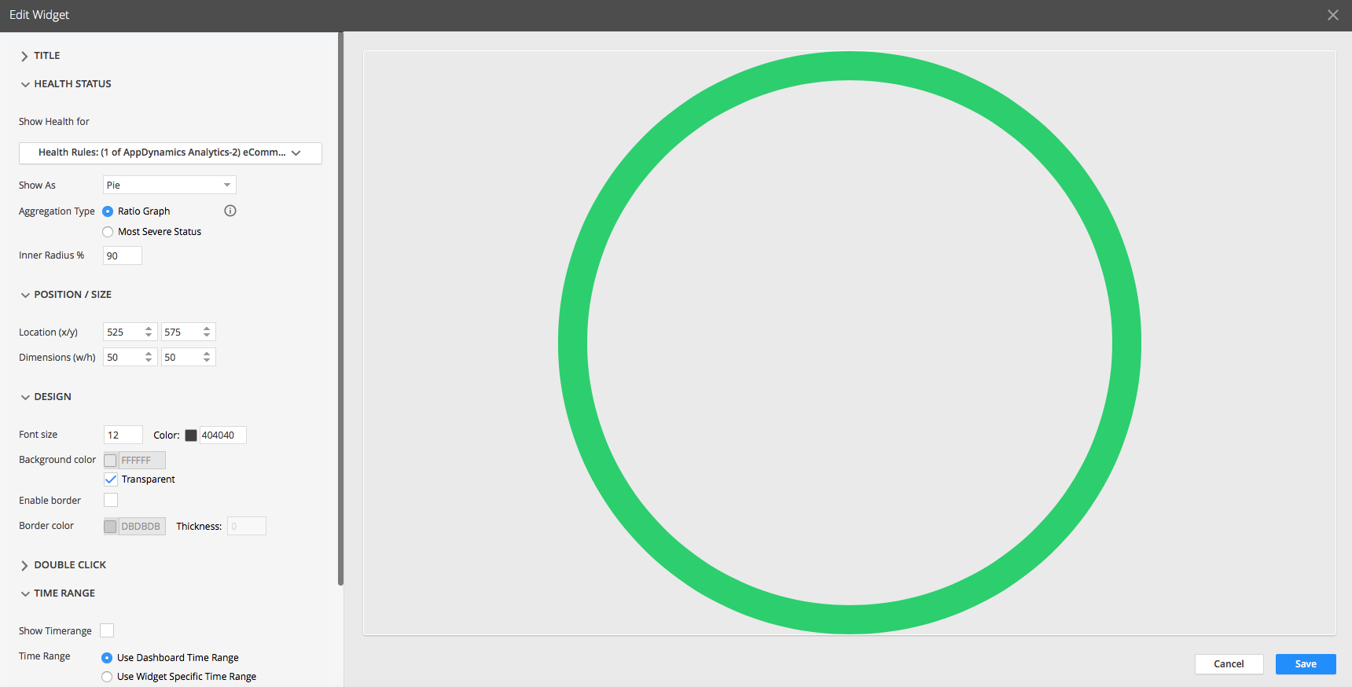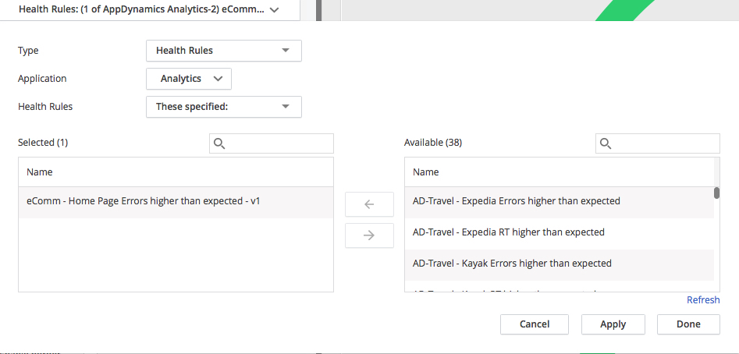

1. Complete the mapping for the following Health Status widgets to the respective Health Rules for release v1 (created in step 11):  
     
   -eComm - Check Out RT higher than expected - v1  
   -eComm - Check Out Errors higher than expected - v1    
   -eComm - Home Page RT higher than expected - v1  
   -eComm - Home Page Errors higher than expected - v1    
   -eComm - Login RT higher than expected - v1  
   -eComm - Login Errors higher than expected - v1
2. Next to the right funnel widget, use the health status widget to link with the respective average response time and the percentage of defective transactions Health Rules for release v2 (created in step 12):  
     
     
     
     
   -eComm - Add To Cart RT higher than expected - v2  
     
     
     
     
     
   -eComm - Add To Cart Errors higher than expected - v2

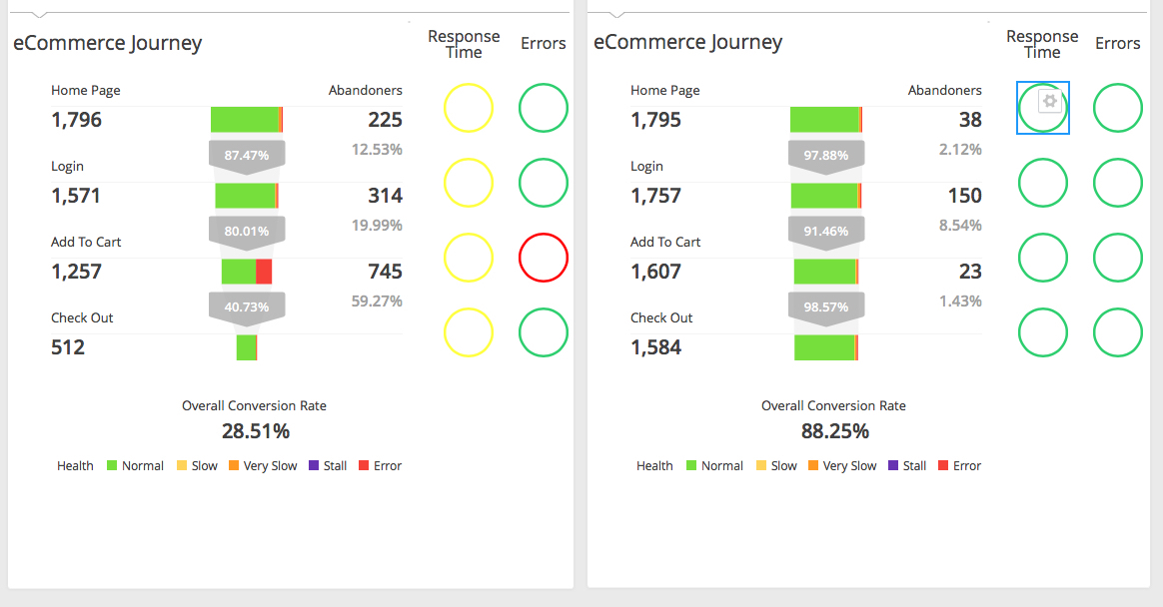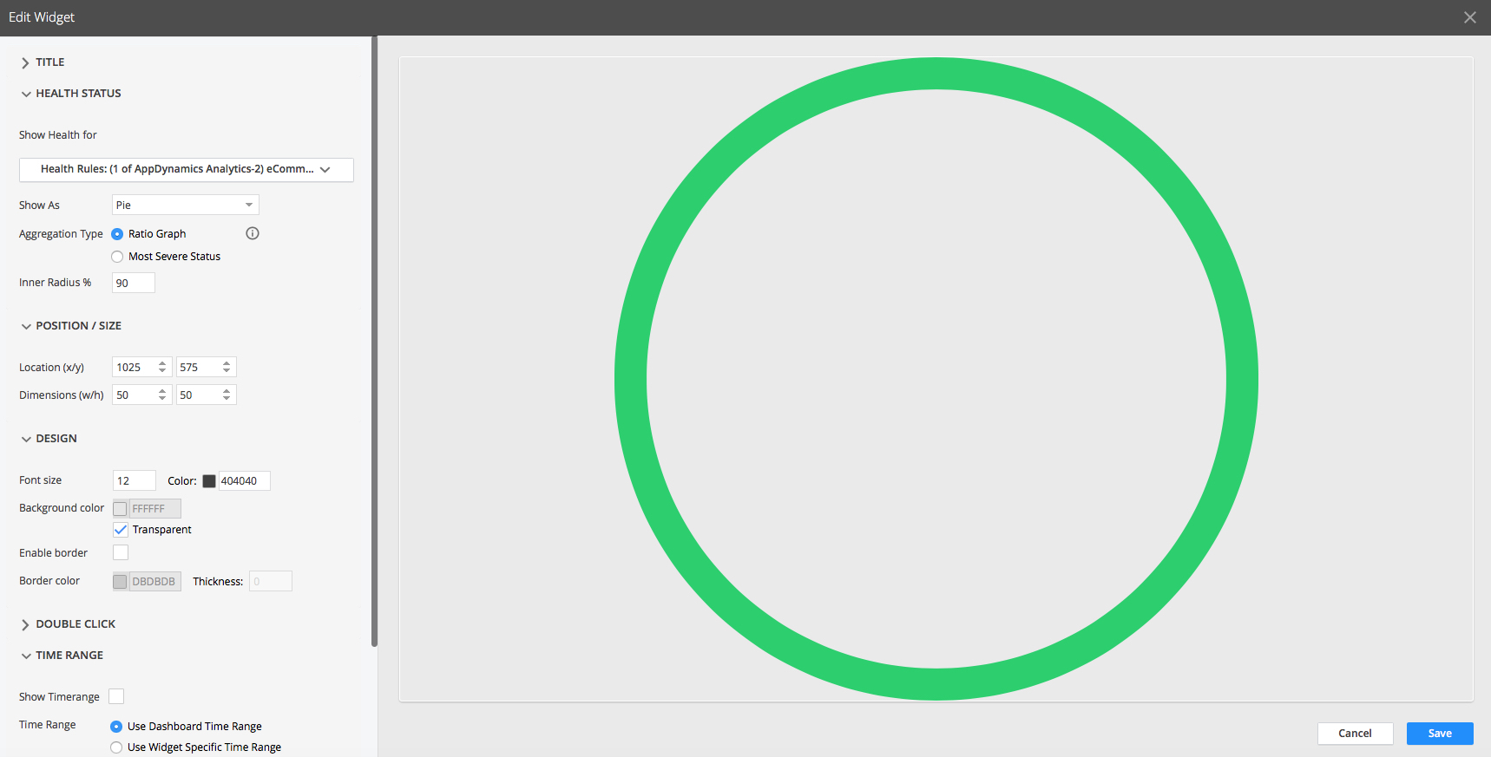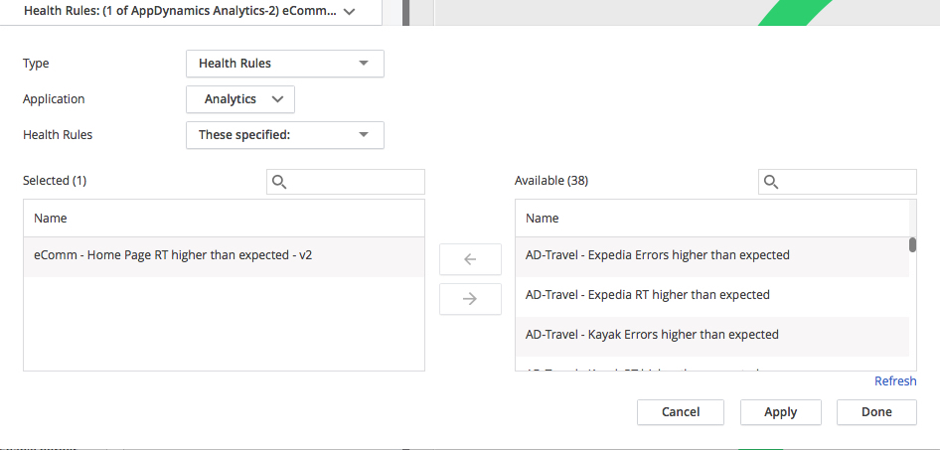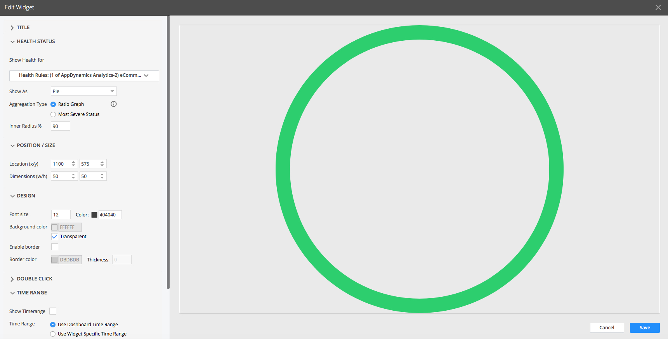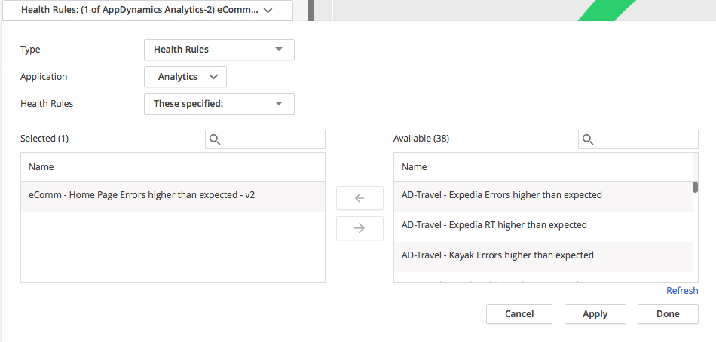

1. Complete the mapping for the following Health Status widgets to the respective Health Rules for release v2 (created in step 12):  
     
   -eComm - Check Out RT higher than expected - v2  
   -eComm - Check Out Errors higher than expected - v2  
   -eComm - Home Page RT higher than expected - v2  
   -eComm - Home Page Errors higher than expected - v2    
   -eComm - Login RT higher than expected - v2  
   -eComm - Login Errors higher than expected - v2
2. Align and change order of the widgets as required
3. This is how it should look our dashboard once completed

